**Deliverable 3**

**Mester Darius**

**Robot Management Website**

1. Dynamic Behavior

Scenario 1: "User logs in"

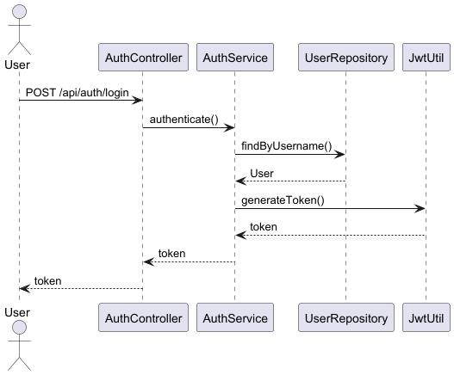

Communication Diagram

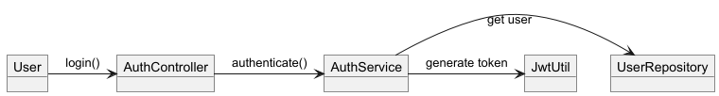

1. Class Diagram

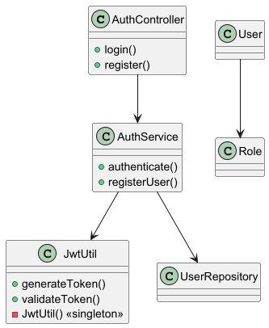

1. Data Model (ER Diagram)

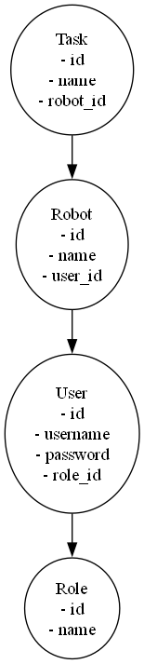

1. **System Testing**

### Testing Methods:

**Using predefined java classes to ensure that those classes work:** instead of making our own classes, we use predefined Java classes. (exception being the websocket which had 3 moderate warnings => use a custom defined low-level websocket).

**Unit testing**: testing methods in isolation (e.g., **AuthService.authenticate()**).

**Integration testing**: test combined components (e.g., login flow).

**Simulating user actions**: simulate real user behavior (e.g., logging in from frontend)

| **ID** | **Test Case** | **Expected Result** |
| --- | --- | --- |
| TC1 | Login with correct credentials | 200 OK + token returned |
| TC2 | Login with wrong password | 401 Unauthorized |
| TC3 | Register new user | 201 Created |
| TC4 | Create robot as user | 200 OK + robot created |
| TC5 | Unauthorized access to /api/user | 403 Forbidden |

## ****Future Improvements****

**Share code between users**

**Real-time analysis** on how robot behave

**Make the AI not provide** the already defined classes (prompt optimization)

**Mobile version** of the app (not in priority list)

**Export robot task logs to Excel/CSV**

## ✅ ****6. Conclusion****

The webapp manages users, robots, and tasks, with role-based access, JWT authentication, and real-time WebSocket support for login activity monitoring.

Each User will have acces only to it’s robots and it’s robots tasks, and the admins will have acces to all the database (including the users).

Creating tasks is where the app is really interesting and it does that either by writing in the task prompt, or by using Speech to Text. Then the user input will go to OPENAI to generate Micro:Bit code, then using Selenium automation will go and upload that code. There is also an option to see the code, which uses Selenium to open the browser and to go to that specific code.